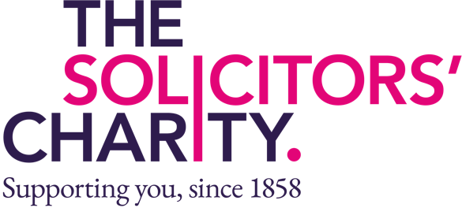
Donation Form

Boost your donation by 25p of Gift Aid for every £1 you donate
Gift Aid is reclaimed by the charity from the tax you pay for the current tax year. Your home address is needed to identify you as a current UK taxpayer
I want to Gift Aid my donation of £______________ and any donations I make in the future or have made in the past 4 years to:
The Solicitors Charity

In order to Gift Aid your donation you must tick the box below
I want to Gift Aid my donation

I am a UK taxpayer and understand that if I pay less Income Tax and/or Capital Gains Tax in the current tax year than the amount of Gift Aid claimed on all my donations, it is my responsibility
to pay any difference.

Please make cheques payable to The Solicitors’ Charity

My details

Title |  | First name or initial/s |  | Surname
Home Address
 |  |  |  | Postcode
Email

Please notify us if you:

- Want to cancel this declaration
- Change your name or home address
- No longer pay sufficient tax on your income and/or capital gains to sustain Gift Aid on this donation

If you pay Income Tax at the higher or additional rate and want to receive the additional tax relief due to you, you must include all your Gift Aid declarations on your Self-Assessment Tax Return or ask HM Revenue & Customs to adjust your tax code.

Thank you!
May we contact you?

From time to time, we’d like to contact you. Please use this form to make us aware of your preferences so that we can properly respect your privacy (please tick as appropriate)
I am happy for The Solicitors’ Charity to contact me from time to time to keep me informed about its work.
I am happy for the The Solicitors’ Charity to contact me occasionally about fundraising activities and campaigns, such as in respect of legacies.
I am happy for the The Solicitors’ Charity to contact me in relation to social events including events aimed at recruiting The Solicitors’ Charity Area Representatives.

Privacy statement
The Solicitors’ Charity is committed to not only ensuring that it meets all legal requirements
but also that it establishes a culture of excellent practice regarding personal information about
its supporters.
The processing of information collected via this form is registered with the Information Commissioner’s Office and details are collected and stored in keeping with The Solicitors’ Charity’s data protection policy for the following purposes:
- the purpose for which it was collected.
- In accordance with the choices that you have selected above (i.e. news updates, fundraising activities and/or social events)
- to respond to your enquiries.
- any disclosures required by law.
The Solicitors’ Charity does not sell or supply data to third parties. Your data will only be passed onto specific agencies outside The Solicitors’ Charity that work with us as an integral part of our charitable mission. You may request access to or amend any personal information that we hold about you at
any time.

Please return this form to:
The Solicitors’ Charity
1 Jaggard Way
London Email: sec@thesolicitorscharity.org Tel: 020 8675 6440
SW12 8SG

